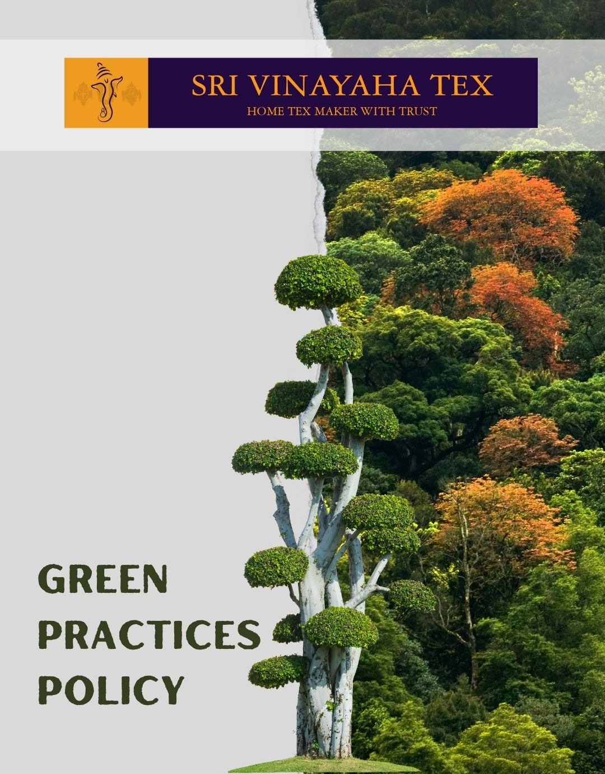

TABLE OF CONTENTS
PROLOGUE 2
SCOPE 2
POLICY DECLARATION 2
INITIATIVES AND TARGETS IN ALIGNMENT WITH SDGs 3
PERFORMANCE REPORTING 4
REVIEW MECHANISM 4

PROLOGUE

At Sri Vinayaha Tex, a global supplier and exporter of Indian Home Textile Products, is dedicated to maintaining the highest standards of environmental stewardship. We recognize our responsibility to minimize our environmental impact and commit to sustainable practices across our operations. Our products, crafted from 100% Cotton, 100% Polyester, and Cotton/Polyester blends, are manufactured using environmentally responsible methods. We are devoted to integrating sustainability into every aspect of our business, ensuring that our practices promote the well-being of the environment, our consumers, and the communities we serve. Through continuous improvement and adherence to global environmental standards, we strive to lead the textile industry towards a more sustainable future.

SCOPE

This Policy is applicable to following sites and all of its employees, workers, sub-contractors and other stakeholders:

Sr. No. | Site | Address
1 | SHRI VINAYAHA TEX
2 | SHRI VINAYAHA TEX

POLICY DECLARATION

Sri Vinayaha Tex is committed to integrate environmental considerations into all aspects of our business operations. We aim to reduce our environmental footprint through continuous improvement and adherence to best practices in sustainability. Our policy sets forth specific qualitative and quantitative targets to guide our efforts and ensure accountability. Our baseline year for evaluating and tracking progress in the environmental areas is 2023.

INITIATIVES AND TARGETS IN ALIGNMENT WITH SDGs
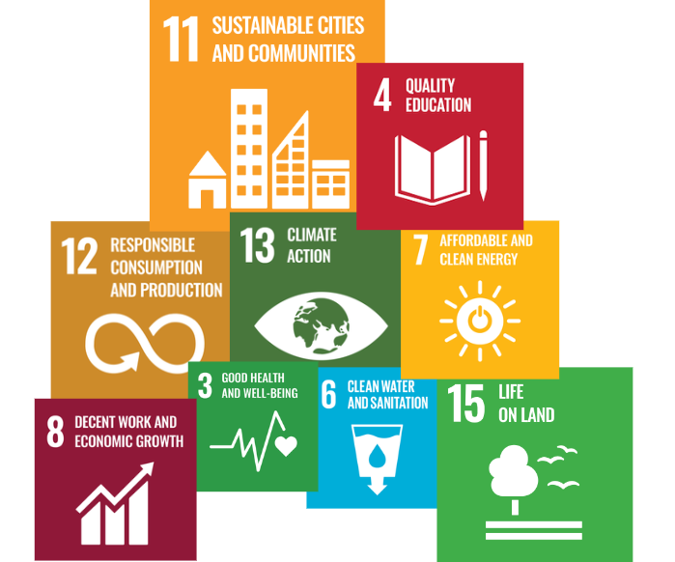

- Implement water-efficient technologies in dyeing and weaving processes.
- Reduce water consumption in dyeing and weaving processes by 25% by year 2030.
- Achieve 50% water recycling rate in all facilities by year 2030.
- Foster a culture of waste minimization and resource efficiency within the company.
- Achieve a 70% recycling rate for all production and packaging materials by year 2030.
- Regularly monitor and report air quality metrics to ensure compliance and transparency.
- Reduce carbon emissions from manufacturing processes by 30% by year 2030.
- Engage with suppliers to improve their sustainability practices and standards and develop a robust supplier code of conduct focused on sustainability.
- Increase procurement of organic and recycled materials by 30% by year 2030.
- Promote the adoption of energy-efficient technologies and practices in all facilities and also educate the employees for it’s implementation.
- Increase the use of renewable energy sources to account for 40% of total energy consumption by year 2030.
- Promote the use of eco-friendly and non-toxic chemicals in all manufacturing processes.
- Decrease material waste by 30% by year 2030.
- Increase green cover around manufacturing facilities by 25% by year 2030.
- Support conservation projects and initiatives that protect local ecosystems.
- Ensure all products are free from harmful substances and provide transparent information to consumers about product safety and environmental impact.
- Achieve a 98% customer satisfaction rate related to product safety by year 2030.
- Conduct regular training programs to ensure all employees are aware of compliance requirements.
- Collaborate with local organizations to support environmental initiatives.
- Organize 15 community environmental events by year 2030.

PERFORMANCE REPORTING

The performance reporting will give details of progress in resource efficiency, highlighting reductions in material waste and supply chain improvements. It will include updates on key environmental metrics such as energy usage, carbon emissions, and water conservation, alongside advancements in waste and chemical management, focusing on reduction, recycling, and safety.

REVIEW MECHANISM

The Green Practices Policy will be reviewed annually by the Environmental Manager which will involve data collection on key performance indicators, stakeholder feedback, and performance evaluation against targets. The findings will be documented in a detailed report, leading to necessary updates and adjustments in the policy. Revised policies and targets will be communicated to all stakeholders to ensure integration into operations, fostering continuous improvement in sustainability practices

REV. No. 01

EFFECTIVE FROM: 01.01.2024 NEXT REVIEW DATE: 01.01.2025
APPROVED BY: PRESIDENT - OPERATIONS

